Screenshots of jconsole for Qpid

New Connection: The following screen will popup when jconsole is started from command prompt (prompt$ jconsole).

Go to the remote tab and enter the host and the port.
Local Process will also show the Qpid server process (org.apache.qpid.server.Main) if the server is running on the same machine.

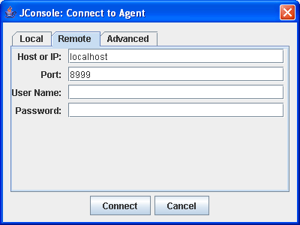

Browsing Qpid process: The following screen gets displayed when the connection is established. The Qpid server management process is listed on left hand side of the screen with name: org.apache.qpid

Note: If the jconsole is started with host and port (prompt$ jconsole <hostname>:<port no>), then this screen will pop up.

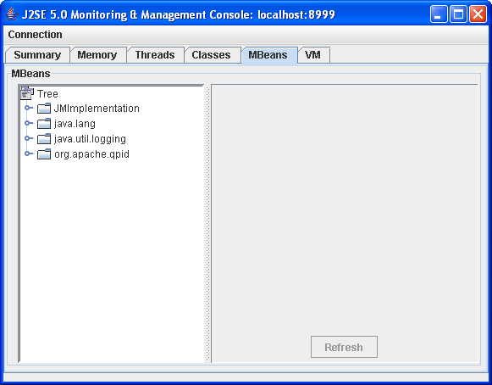

Browsing managed objects: Select a managed object to manage and monitor the managed features. The following screen displays the attributes of a managed object.
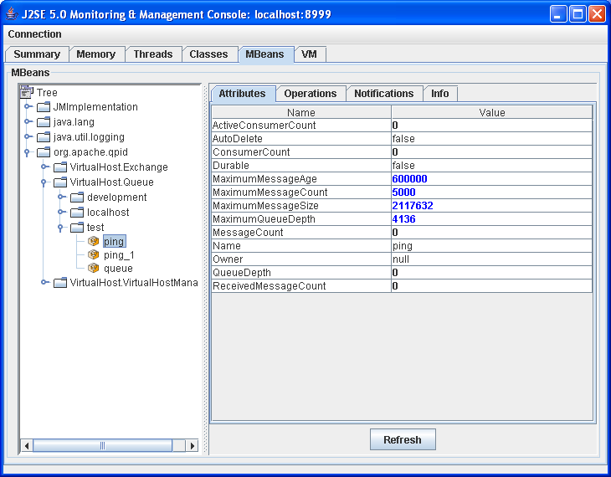

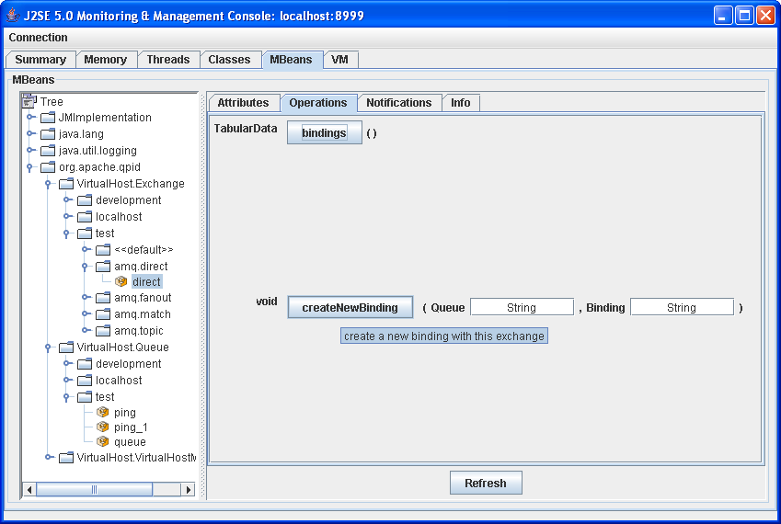
The description can be seen by pointing the cursor to an operation.

Editing fields: Editable attributes of managed objects can be updated with new values. E.g. Setting the MaximumMessageCount to 5000. Notification will be received if messages on the queue exceed 5000.

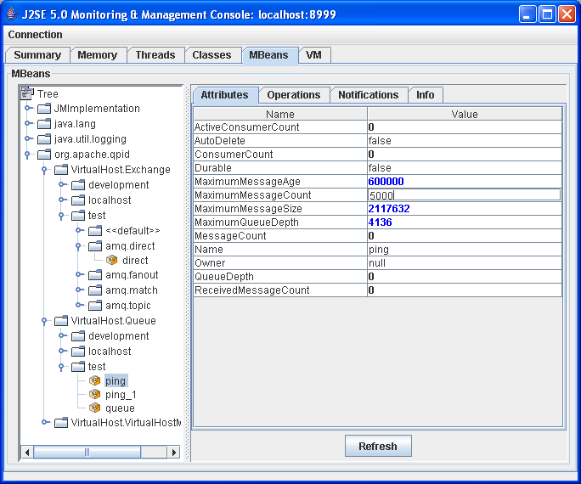

Receiving Notifications: To receive notifications sent by a managed object, click “Subscribe”. All received notifications will be listed on Notifications screen.
